***Windows Tools for Debugging:***

***Process Explorer, Process Monitor, LogonSessions, Autologon, Psexec, PSTools, RegMon, Whois, SysMon***

* **PROCESS EXPLORRER**

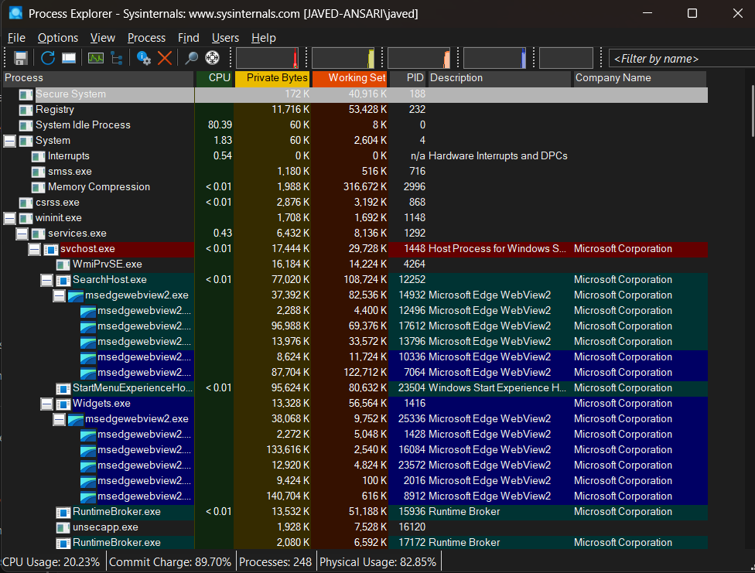

* **PROCESS MONITOR**

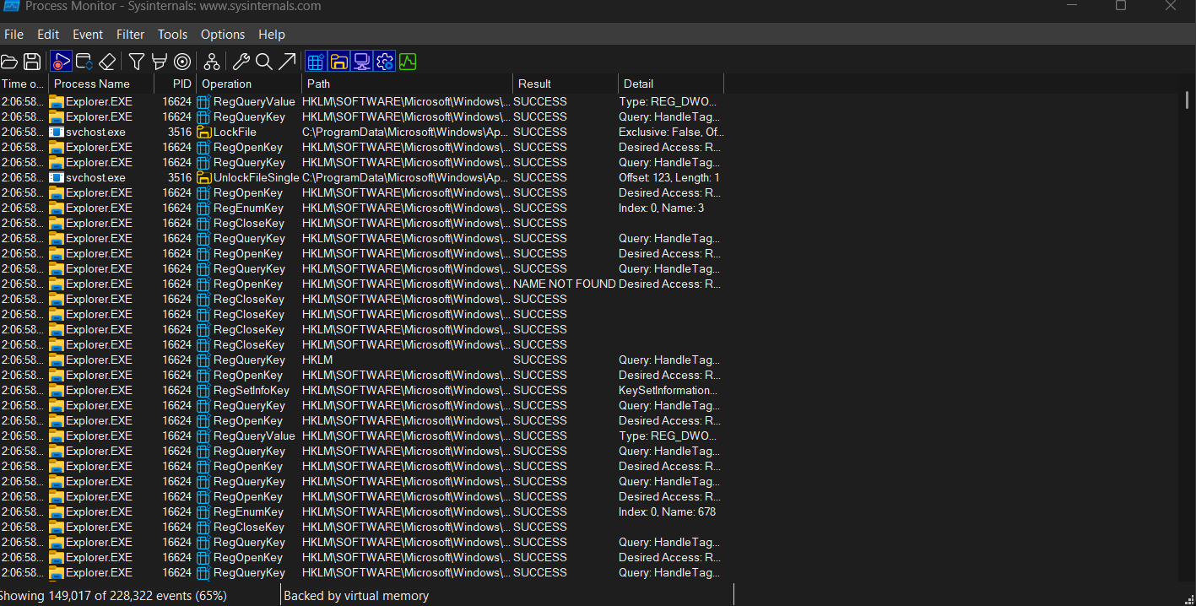

* **PS TOOLS**

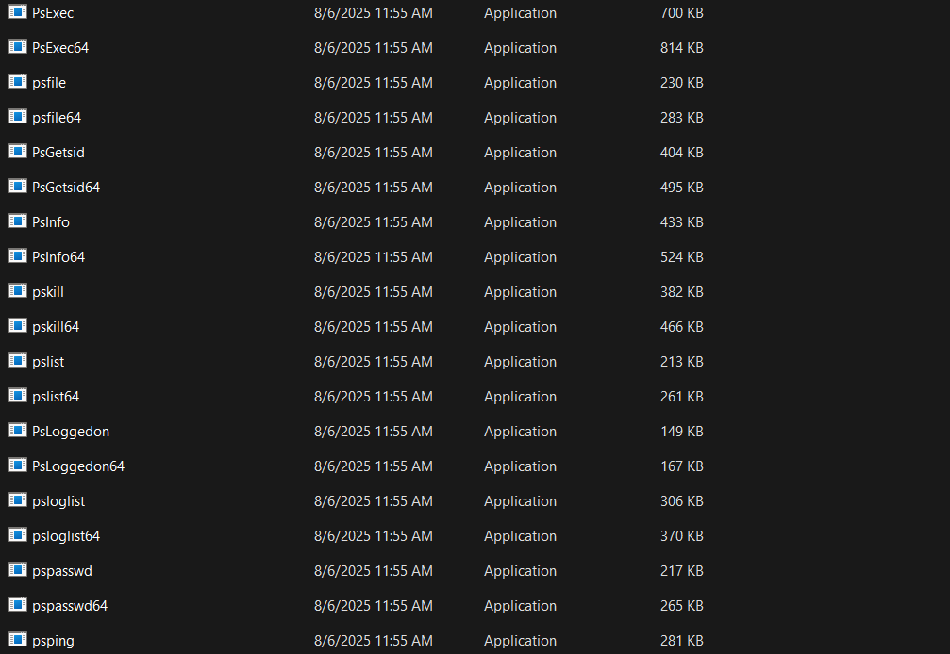

All PS TOOLS

* **REG MON**

Comes under Process Monitor

* **WHOIS**

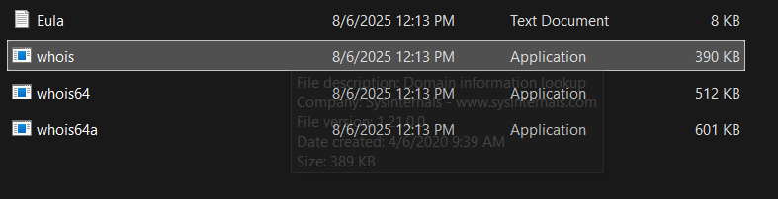

* **SYS MON**

